NORTH WEST UNIVERSITY

FACULTY OF NATURAL AND AGRICULTURAL SCIENCE

DEPARTMENT OF COMPUTER SCIENCE

TUMELO MOIPOLAI

26122197

REMOFILWE SHARON MOSADI

26718545

JULIA MASENYA

26315718

CISM 314

INTRODUCTION TO COMPILER DESIGN

Practical 4

Parsing and translating binary expressions

**INTRODUCTION**

This is a report for parsing and translating binary expressions written in **Pascal code** using **Sublime.** Sublime was used as a text editor where the Pascal program was coded and later to be loaded into DOSBox. Parsing is the process of analysing a string of symbols, either in natural languages, computer language or data structures, conforming to the rules of a formal grammar. A parser is a compiler or interpreter component that breaks data into smaller elements for easy translation into another language.

In this practical, we created a parser that translate general expressions for addition and subtraction of two numbers like (4+2 or 6-9) using DOSBox. In this case, the DOSBox was used as an environment where the program code can be loaded, executed and run.

Figure 1.1

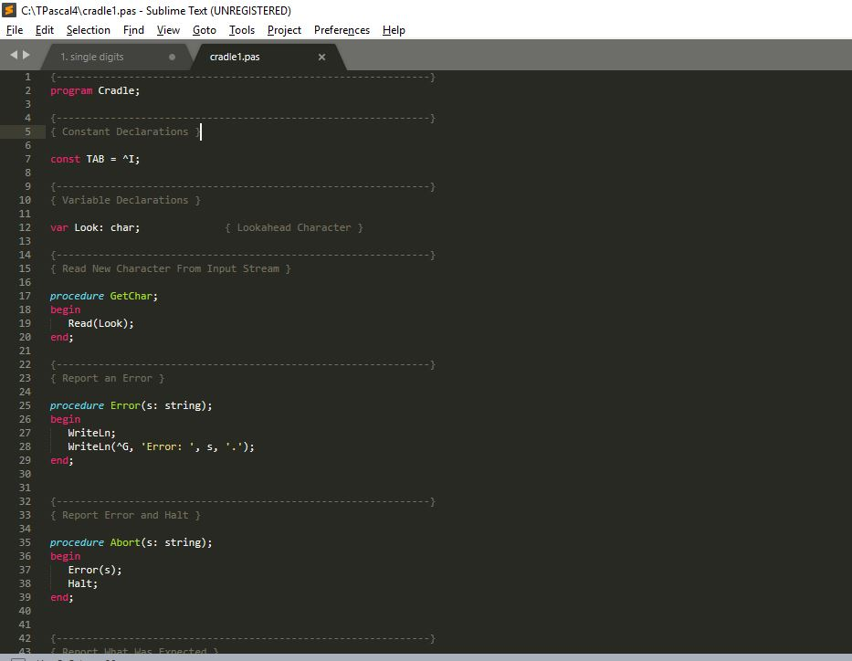

Figure 1.2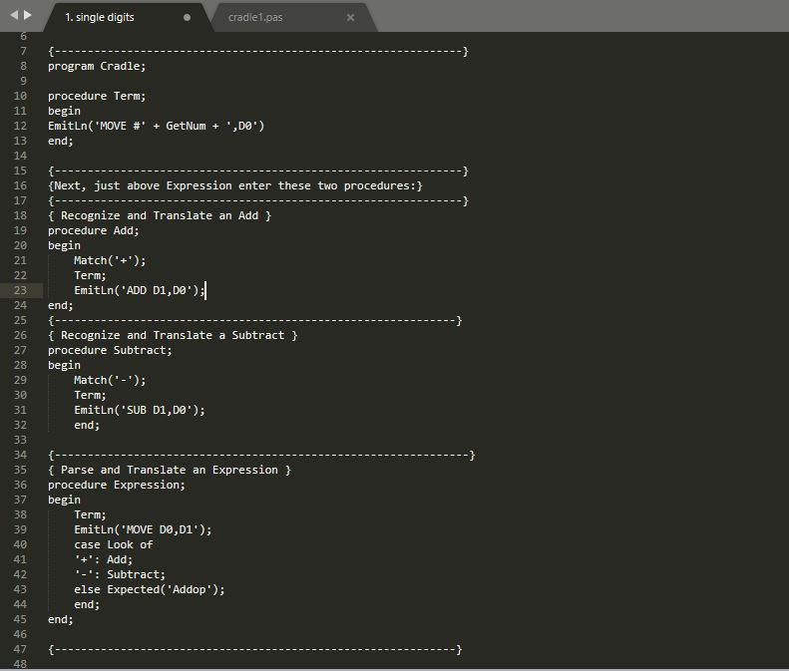

Figure 1.3

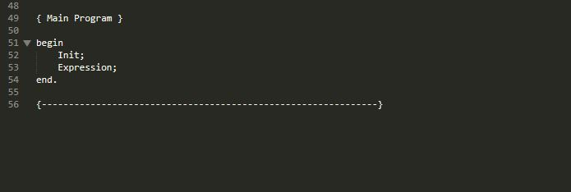

Figure 1.1- 1.3 shows the program in subline text editor where the expression were coded.

Figure 2

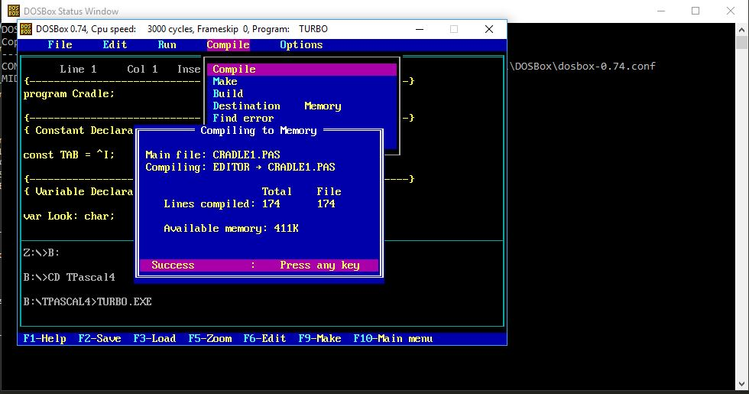

Figure 2 shows the cradle code being loaded into and then compliled into DOSBox.

Figure 3

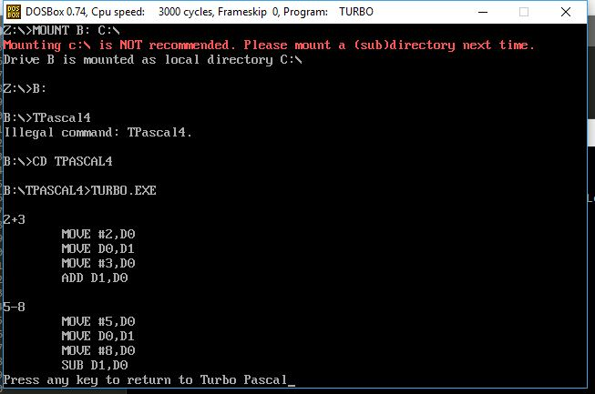

Figure 3 shows the correct assembly for translating binary expressions for addition and subtraction such as “2+3” and “5-8”.

Figure 4

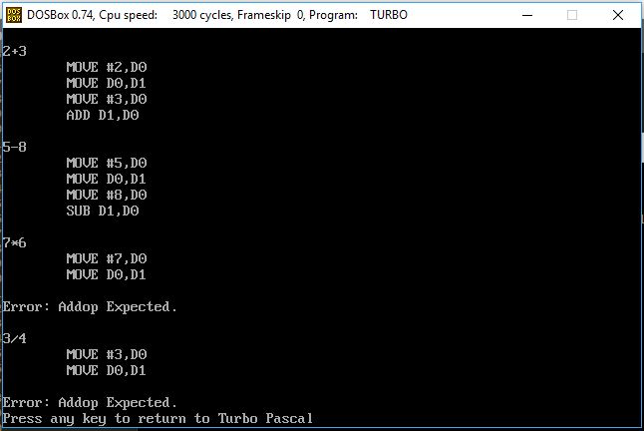

Figure shows that, since multiplication and division are not declared on the program, when executed they resulted in an error.

DOSBox is an emulator program which emulates a PC compatible computer running a DOS operating system. DOSBox is a command line program configured by command line arguments where one is able to edit a plain text configuration file. DOSBox was downloaded and installed in a computer and the DOSBox served as the command line environment. This is where the cradle code was loaded and compiled.